EXPERIMENT- 9
NAME: ZARAA JUHI SAAI K ROLL NO:240701044

Aim:
To design and implement a registration form that validates user input such as name, email, phone number, and password using HTML, CSS, and JavaScript.
Procedure:
- Created three files: index.html, style.css, and script.js.
- Designed a registration form using HTML with fields like name, email, phone, password, and confirm password.
- Styled the form using CSS to make it neat and readable.
- Wrote JavaScript code to check the input values.
- Displayed error messages for invalid inputs.
- Prevented form submission if any field is incorrect.
- Run the program by opening index.html in the browser.

Program:
- Index.html
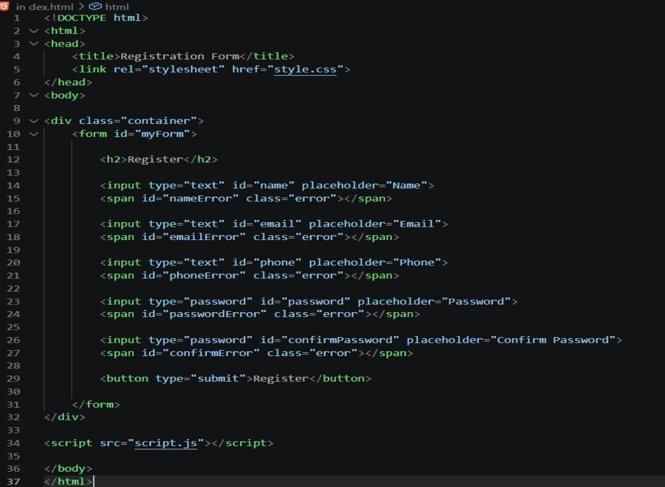

- style.css
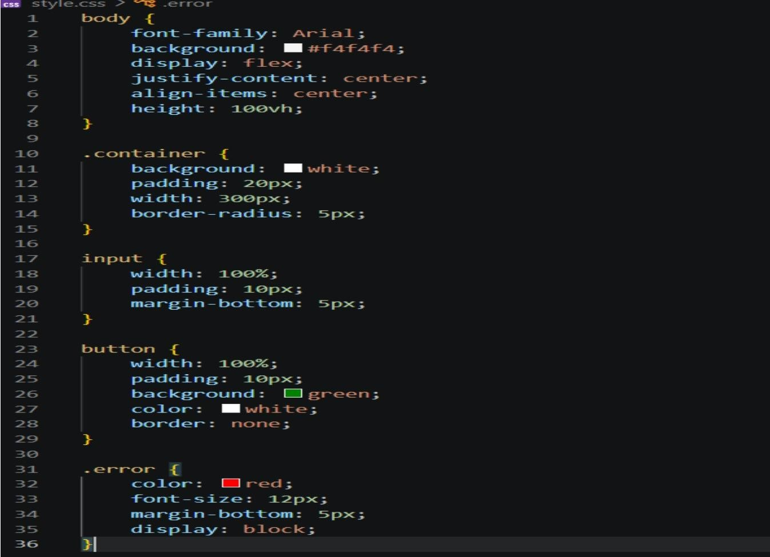

- script.jsOutput:


- For valid mail and phone no
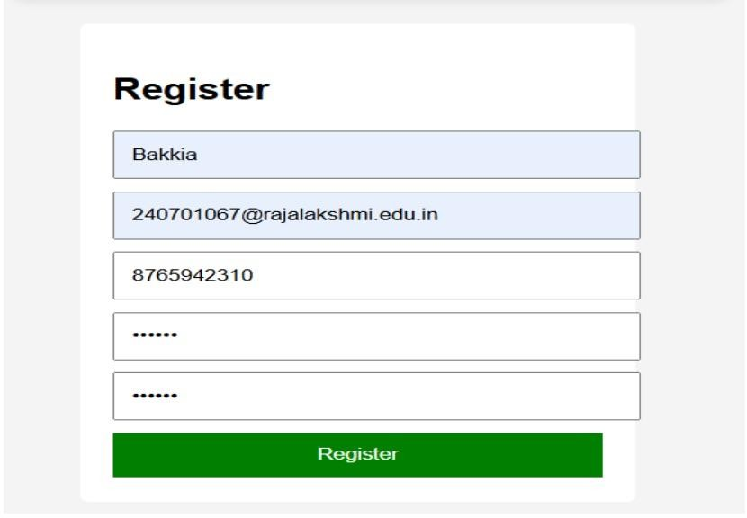
- For invalid mail3.For invalid phone number
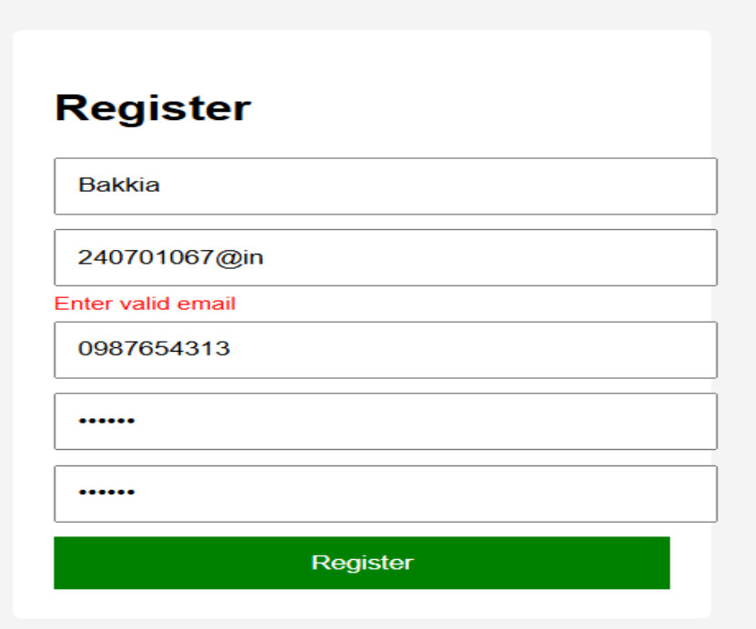

Result:
The registration form was successfully created and validated.All input fields were checked correctly, and appropriate error messages were displayed for invalid entries. The form submitted successfully when all inputs were valid

